Module 2

# Lesson 4

1. 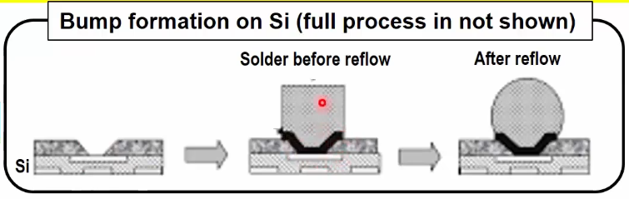Flip Chip Packaging

* First, we apply under ball metallisation which creates a base.
* Then apply a metal in a pattern.
* Finally, apply the solder and pattern again.
* After that we apply the process of reflow where the solder goes through a high temperature furnace and becomes a bump on the backside of the chip and there are many such bumps.
* Then you flip the die with the solder balls.

Now we need to place the die on the substrate but before we can do that we need to create a surface where the balls can connect with the substrate.

* So first we create pads on the substrate’s surface and apply Flux. Flux is an environment used to protect the dies.
* After making the pads we can use two things to join the substrate and die.
  + We have to use heating and compression.
* Here we have used thermocompression to join/solder the balls to the pads.
* Then we spray the chip with a solvent to remove the flux as we no longer need it since the connections have been made.
* Then we dispense underfill to make connections between the die and substrate.
* After that we cure the underfill by heating the chip.
* Finally, we add the molding compound.

The process through which the flip chip is bonded to the substrate is called the Mass Reflow and Thermo-Compression Process.

* Then we mark the chip which will help in identification later.

Now we need to create bumps on the substrate so that the chip can connect with the outer world.

* For that first we flip the package.
* Then we do the ball mounting in its regular fashion.
* Finally we put the package through reflow and get our final result.